**Getting Start**

**1: Download code from our repository**

**2: Run sailboat_main.py**

**3: To Start manual control:**

Click the highlighted icon for manual control

Control setting:

G: Start

S: Stop

Up/Down: Sail

Left/Right: Rudder

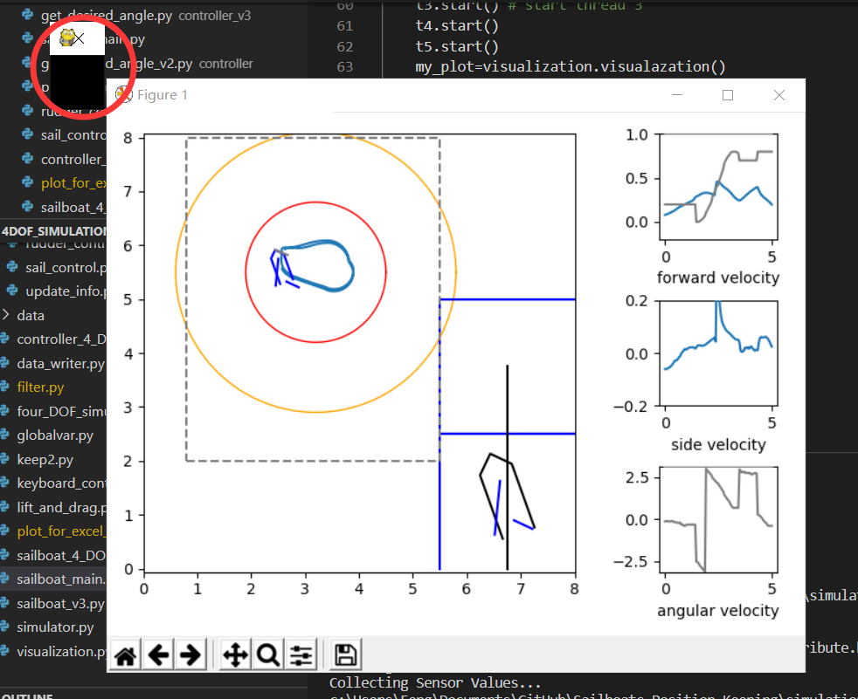

**4: To save data, enter file name after termination.**

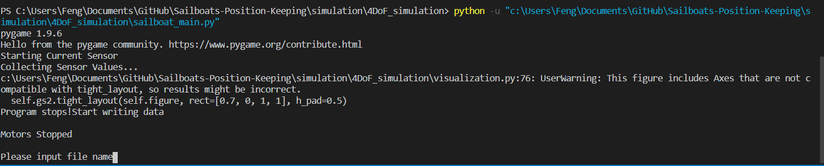

**5: Change wind speed and directions: In Simulator.py:**



**6: Program structure**

